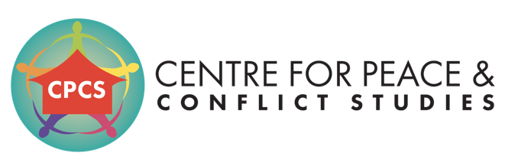
Strengthening strategic interventions into violent conflict with the overall aim of fostering sustainable peace in the Asia region

Invitation for Tender Financial Audit on Projects

I. Background

CPCS is a Cambodian NGO working in the field of peacebuilding and conflict transformation in Asia. Our mission is to strengthen strategic intervention into armed conflict with the overall goal of reaching sustainable and positive peace in the Asia region. CPCS is home to a range of interconnected programmes and initiatives that are informed by on-going analysis and consultation with a myriad of local partners from the various contexts in which CPCS works, including Myanmar, the Philippines, Cambodia, and Sri Lanka. CPCS is an outsider organisation, and conducts research and delivers resources that are not available within the communities, thus not competing with local organisations. Being based in Cambodia also provides space to bring participants of our interventions out of their contexts when hosting programmes, allowing for more freedom to critically reflect on their context and strategies for moving forward towards peace.

CPCS focuses on demand-driven interventions that are informed by critical analyses and tailored to the needs of stakeholders within their conflict contexts. To enhance the sustainability of outcomes, CPCS prioritises long-term accompaniment over one- off programmes. Through this approach, CPCS expands safe spaces and creates platforms for dialogue and understanding, which are essential for establishing mutual trust and an environment conducive for transforming conflict. CPCS also works to build relationships with key individuals and institutions directly involved in peace processes, as well as key actors driving or influencing conflicts. These relationships provide a myriad of perspectives on conflict dynamics as well as opportunities to support and strengthen locally led efforts. New projects are frequently identified through feedback from these partners and are designed to fill identified gaps, strengthen conflict transformation approaches, or to bring together key actors to develop new strategies for reducing conflict.

II. Context and Purpose

The Centre for Peace and Conflict Studies is looking for external audit firm to provide audit on projects from 2022 thru 2023 The purpose of this audit is to provide opinion whether financial statements are fairly stated in accordance with accounting standards and follow funding requirement.

Objectives & Deliverables

The Objective of global financial statement/Audit are:

  - To comparative budget flow, practices, fixed asset use with organization’s policies /procedure
  - Finding potential Error or misstatement
& propose recommendation to improving next plan.
  - To finding key strengthening organizational management system.

Deliverables:

Scope of global financial statement/Audit:

  - Desk review supporting document with compare with currently practice (Eg: Policies/procedure, invoice …..Financial report…ect ).
  - Meeting with management team and or BoDs, staff to review/clarifying key identified.
  - Develop finding report including recommendation.

Methodology

The consultant will coordinate with the CPCS Finance Manager.

Timeframe and Budget

The consultation services shall be available between 1 January 2023 to 31 January 2024.

Remuneration shall be based on consultant experiences. All expenses associated with activity (travel, accommodation, meals, etc.) will be covered by CPCS.

- TECHNICAL REQUIREMENTS FOR APPLICATIONS

KEY requirement Experiences:

  - Consultant firm experiences at least 5 years
  - Register with Cambodia law & or KICPAA, ACCA.

Deadline: Interested consultant firm should send proposal with key activities, specific timeline or work plan, objective, experiences and budget etc. and simple report or Team’s CV to centrepeaceconflictstudies@gmail.com by 20th December 2022 @5pm. Only shortlisted candidates will be contacted for interview.

